Title | Description of Task, Plant or Equipment
Preparing & Painting Asbestos Sheeting | Preparing ACM for painting

Personal Protective Equipment (PPE) & Hazards
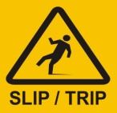
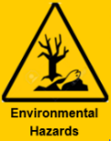
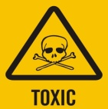

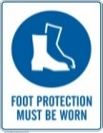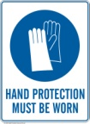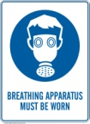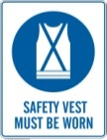
Licence Required | Y ☐ N |  | Licence / Qualification Type | Asbestos Awareness Training |  |  | Competency Verification |  | Y ☐ N
Workers are to be instructed in the associated hazards and risks of asbestos prior to working in or around asbestos.
Potential risks include |  | - Lung cancer |  |  | - Asbestosis | - Death |  | - Mesothelioma

Steps | Requirements
Pre-start site check  Check the Site Asbestos Register | - Clear work area of all hazards and obstacles  - All Specified equipment and PPE is available  - Establish the extent of preparation required to the substrate prior to painting  - For location and condition of asbestos containing materials (ACM)  - Suspected ACM will be managed as if it is asbestos containing material
Precautions | - ACM in poor condition or pure Asbestos e.g., in the form lagging etc must not be interfered with  - Liaise with client to schedule work so as not to disrupt normal business activity  - If sanding is required a Wet sanding method must be used without abrading surface of the ACM  - Filling of holes or indentations is to be carried out after the first sealing coat is applied  - All paint flakes, dust, plastic, used PPE and used materials and residue must be captured, treated, and disposed of as contaminated Waste  - Do Not Pressure Wash Suspected ACM  - Do Not Dry Broom up Flakes and Dust  - Asbestos (ACM) Awareness training must be completed before completing any Works
Set up | - Establish exclusion zone with appropriate barricades and signage
ACM is in poor condition or soft and crumbling | - Do Not disturb ACM contact you manager for instruction
Existing paint is breaking down | - If required any loose paint can be removed with a scraper, keeping the surface wet with water using a spray bottle to minimise the release of fibres  - Bubbles should be broken at the top and water allowed to flow into the bubble to prevent any dust becoming air borne.  - Larger bubbles on a horizontal surface eg a ceiling should be injected with water prior to scrapping them
Removing peeling paint at height or localised area | 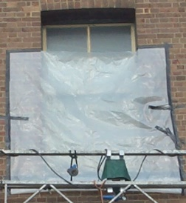  - The use of pockets to capture flakes and dust is recommended
Existing paint is in a sound, stable, and undisturbed condition | - If no airborne dust is produced it does not present a health risk then the surface can be broom washed and recoated in accordance with paint manufacturer’s recommendations.
Apply sealer coating | - Using all PPE apply first coat of sealer to ACM
Clean up of Work Areas | - Mist with water then slowly fold up plastic sheeting / pockets and place in heavy duty plastic bag  - All paint flakes, dust and residue must be cleaned using HEPA vacuum cleaner rated “H” for Hazardous dusts  - DO NOT sweep up dry  - Complete a final wet wipe folding the rag between each stroke  - Ensure waste is correctly labelled
Remove PPE | - Mist all PPE prior to removal, peel overalls off turning inside out as removed  - Lastly remove respirator, take out filters from respirator and place with waste, wet wipe respirator  - ALL PPE is disposed of as contaminated waste
Waste Disposal | - Complete Waste Disposal Chain of Custody form for all waste leaving site  - All waste must be disposed of as soon as is practicable at a site authorised to accept asbestos waste
Recoating surfaces | - Carry out painting in accordance with Paint Manufacturers recommendations
Housekeeping | - Clean up waste and dispose of correctly

